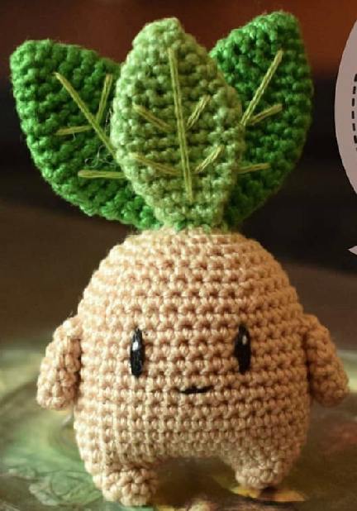**Mandrake Crochet Pattern**

***\*2.5mm Hook\****

**Legs;**

R1: SC5 in MR [5]

R2: SC, Inc x3, SC [8]

Fasten off.

Repeat R1&R2 to make 2nd leg but don’t fasten off.

**Body;**

Ch5 from 2nd leg

R1: SC8 in loops of first leg, SC1 in Ch, Inc x3, SC in Ch, SC8 in loops of second leg, SC1 in Ch, Inc x3, SC [32]

R2: SC3, Inc x2, SC14, Inc x2, SC11, [36]

R3-11: SC around [36]

R12: SC3, Dec, SC5, Dec, SC9, Dec, SC5, Dec, SC6 [32]

R13: SC around [32]

R14: SC3, Dec, SC4, Dec, SC8, Dec, SC4, Dec, SC5 [28]

R15: (SC5, Dec) x4 [24]

R16: (SC2, Dec) x6 [18]

*Stuff*

R17: (SC1, Dec) x6 [12]

R18: Dec x6 [6]

Fasten Off.

**Leaves (Make 3);**

R1: SC4 in MR [4]

R2: (Inc, SC) x2 [6]

R3: (Inc, SC2) x2 [8]

R4: (Inc, SC3) x2 [10]

R5: (Inc, SC4) x2 [12]

**Hands (Make 2);**

R1: SC5 in MR [5]

R2: Inc, SC4 [6]

R3: Inc, SC5 [7]

R4: SC around [7]

R5: SC around [7]

Embroider green veins on the leaves.

Sew leave and hands onto body.

Use black and white threads to embroider the eyes (or use safety eyes).

Embroider the mouth.

R6: (Inc, SC5) x2 [14]

R7: SC around [14]

R8: (Inc, SC6) x2 [16]

R9: SC around [16]

R10: SC around [16]

R11: (Dec, SC6) x2 [14]

R12: (Dec, SC5) x2 [12]

R13: (Dec, SC4) x2 [10]

R14: (Dec, SC3) x2 [8]